TITLE
Author Name *
Affiliation *
Address *

Author Name *
Affiliation *
Address *

* Please keep anonymous for blind reviews
ABSTRACT
The paper must have an abstract. The abstract should be self-contained and understandable by a general reader outside the context of the paper.
KEYWORDS
Maximum of 6 keywords. Separated by semi-colon.
- INTRODUCTION
This document defines the styles and page layout settings that determine the appearance of the proceedings. The use of this template is mandatory.
- BODY OF PAPER
You can add as many chapters as you want (not exceeding the page limit).
2.1 Figures and Tables
Figures should be numbered consecutively as they appear in the text.
Table 1. Font sizes of headings. Table captions should always be positioned above the tables. The final sentence of a table caption should end without a period
Heading level | Example | Font size and style
First level heading | 1. INTRODUCTION | 13 point, bold
Second level heading  Third level heading | 1.1 Printing Area  1.1.1 Text | 13 point, bold  11 point, bold

Figures and Tables should be placed as close to their reference point in text as possible. All figures and Tables must have titles and must be referenced from within the text.
Avoid color images as the proceedings will be printed in black and white.

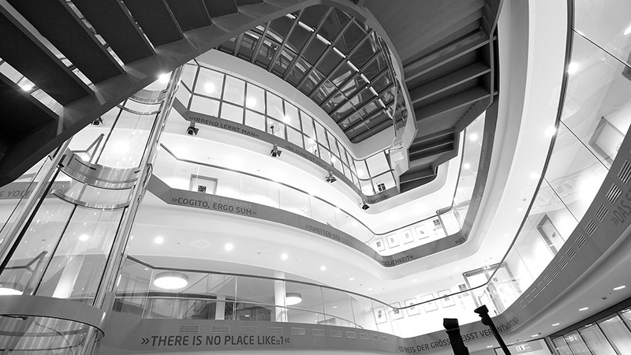

Fig. 1: HPI Main Building

2.1.1 Heading
Headings shouldn’t go deeper than 3 levels.

2.1.2 Length of the Paper
Short papers can have up to five pages including references, full papers can have up to ten including references.
Please double check with the specifications in the specifications of the track to which you want to submit as these might differ from the more general specifications here. See the EMOOCs 2021 home page for more detailed specification.
- CONCLUSION
Clearly indicate advantages, limitations and possible applications.
ACKNOWLEDGEMENT
A brief acknowledgement section may be included here.
REFERENCES
References and Citations should follow the Harvard (or author-date) system convention. Check the examples. If a referenced paper has three or more authors, the reference should always appear as the first author followed by et al.
Book
Author, year. Title (in italics). Publisher, location of publisher.

Journal
Author, year. Paper title. Journal name (in italics), volume and issue numbers, inclusive pages.

Conference paper or contributed volume
Author, year, paper title. Proceedings title (in italics). City, country, inclusive pages.

https://emoocs2021.eu/index.php/call-for-papers/emoocs/

